Data Structure And Algorithum
Exercise 1: Inventory Management System
Create a Product class and use HashMap to perform Add, Update, Delete operations.
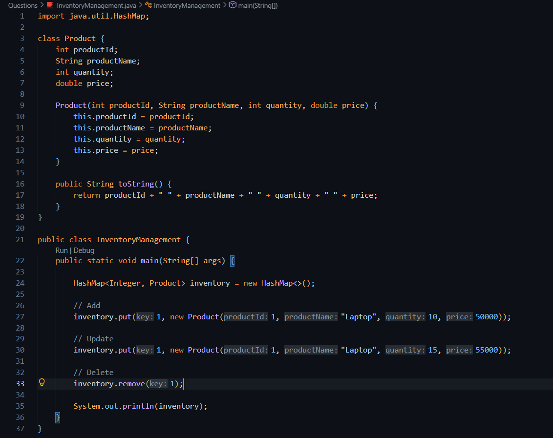
Here output is Empty because -->Product added, Product updated, Product deleted.
HashMap becomes empty.
Exercise 2: E-Commerce Search
Implement Linear Search and Binary Search on products.
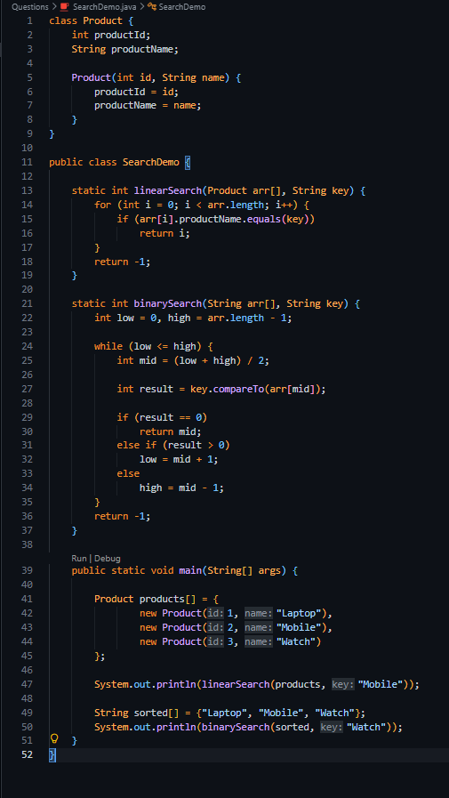
Output---> 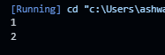
Exercise 3: Sorting Customer Orders
Sort orders using Bubble Sort and Quick Sort.

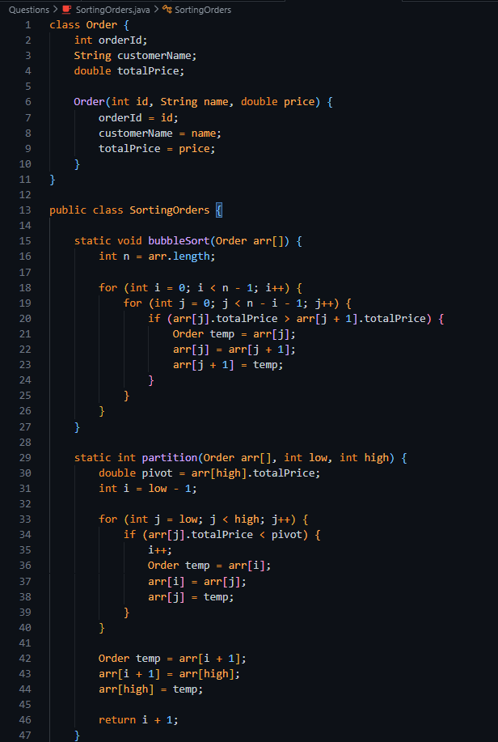
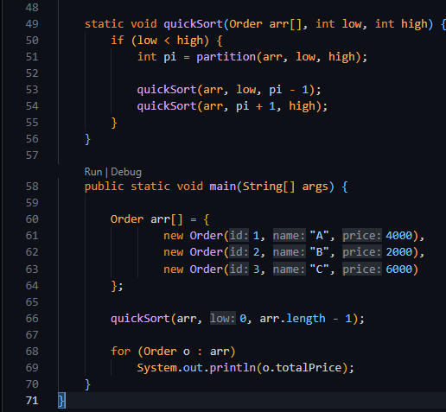
Output ----> 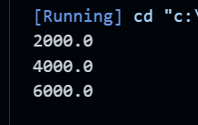

Exercise 4: Employee Management System
Store employees in an array and perform Add, Search, Traverse, Delete.

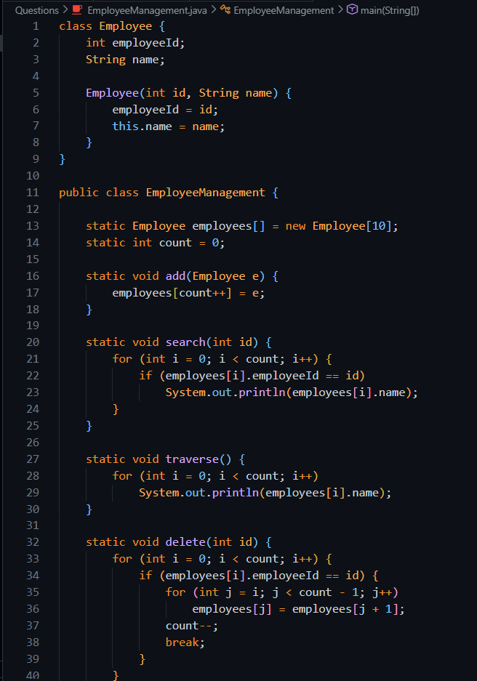
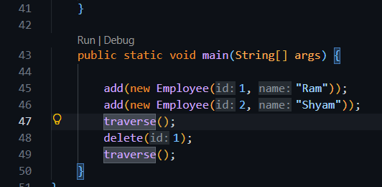

Ouput-----> 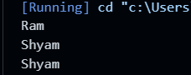

Exercise 5: Task Management System
Implement Singly Linked List for task management.
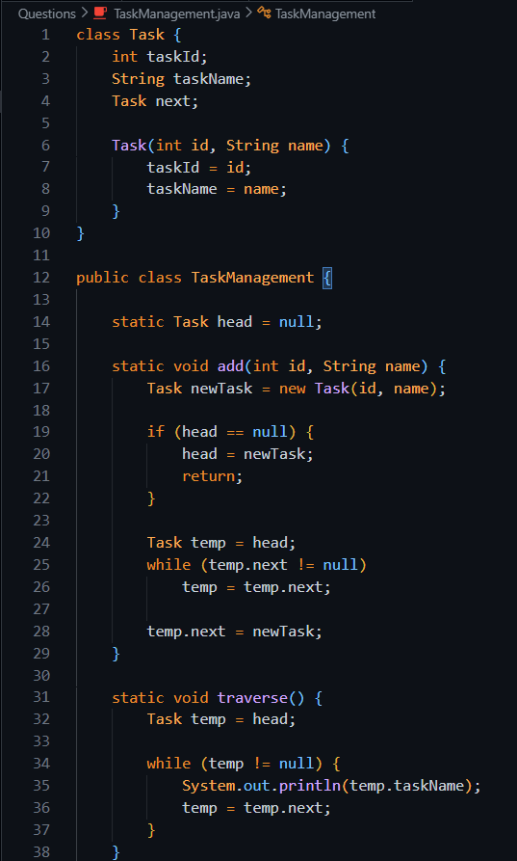
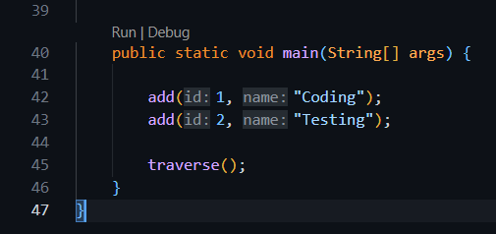
Output---> 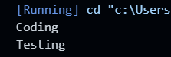

Exercise 6: Library Management System...
Search books using Linear Search and Binary Search.
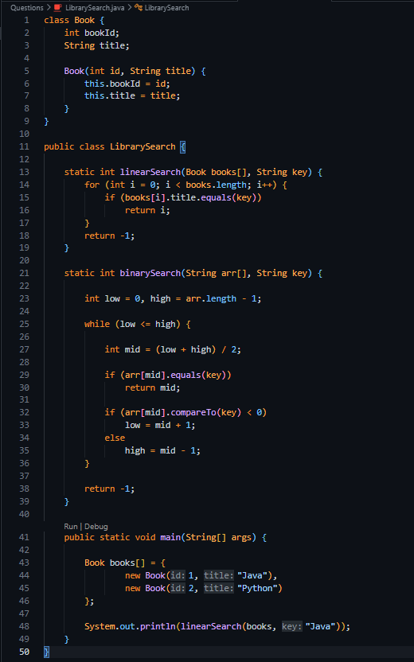
Output--->

Exercise 7: Financial Forecasting
Predict future value using Recursion.
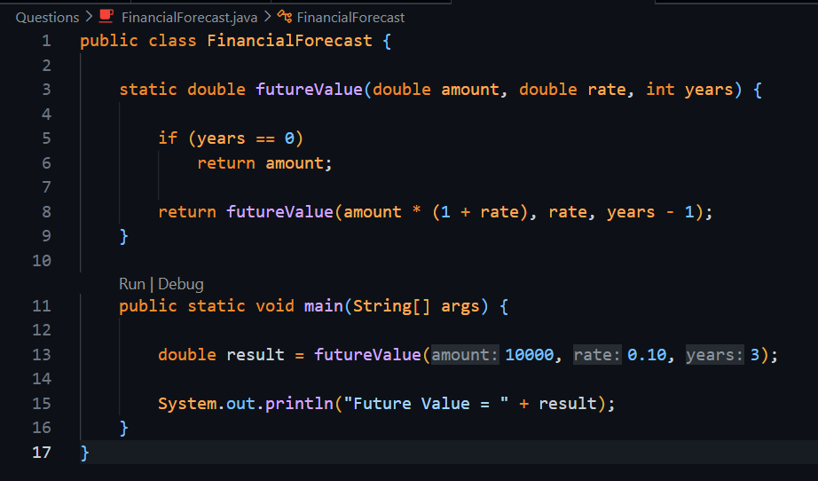
Output---->

